AIML SESSION 10 ASSIGNMENT SUBMISSION

Name of Student : Vaibhav Vijay Kate
Domain/Subject : AIML (Artificial Intelligence & Machine Learning)
College : Government Polytechnic College Washim
Branch : Information Technology
Session : 10

Q1
Q1. Basic Class and Object)
Create a class named Car with:
Attributes: brand and model (set using __init__).
A method display_info() that prints the brand and model.
Create two objects of the Car class with different values and call the method for
both.

Program Code:
# Create a class named Car with:
class Car:
# Attributes: brand and model (set using __init__).
def __init__(self, Brand, Model):
self.Brand = Brand
self.Model = Model
# A method display_info() that prints the brand and model.
def display_info(self):
print(f"Brand: {self.Brand}, Model: {self.Model}")
# Initialize two Car objects and call the method for both
car1 = Car("Toyota", "Corolla")
car2 = Car("Honda", "Civic")
car1.display_info()
car2.display_info()

Output Screenshot: 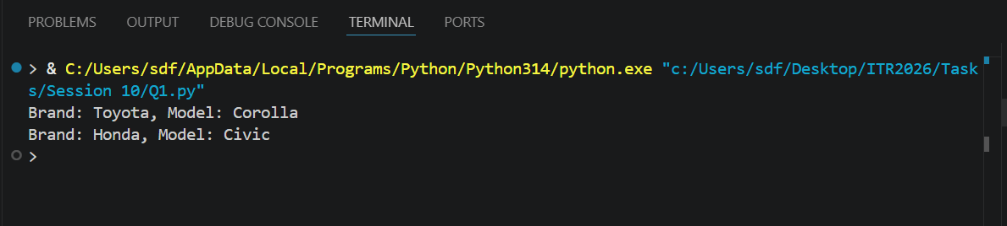

Q2
Q2. Using init Constructor)
Write a class Book that takes title, author, and price as parameters in __init__.
Create a method show_details() to print all the book information.
Create at least two book objects and display their details.

Program Code:
# Write a class Book that takes title, author, and price as parameters in __init__.
class Book:
def __init__(self,title,author,price):
self.title=title
self.author=author
self.price=price
# Create a method show_details() to print all the book information.
def show_details(self):
print("\nTitle:",self.title)
print("Author:",self.author)
print("price:",self.price)
# Create at least two book objects and display their details.
b1=Book("Atomic Habits","James Clear","590")
b2=Book("The Psychology of Money","Morgan Housel","290")
b1.show_details()
b2.show_details()

Output Screenshot: 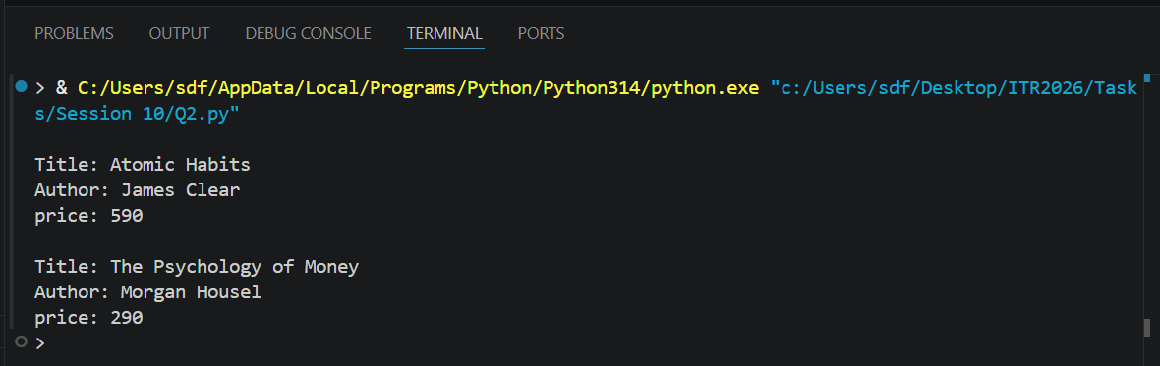

Q3
Q3. Instance Methods and self)
Create a class BankAccount with:
Attributes: account_holder and balance (initialized in __init__).
Methods:
deposit(amount) — add amount to balance.
withdraw(amount) — subtract amount from balance (only if sufficient
balance).
show_balance() — print current balance.
Create an object and demonstrate all methods.

Program Code:
# Create a class BankAccount with:
# Attributes: account_holder and balance (initialized in __init__).
class BankAccount:
def __init__(self, account_holder, balance):
self.account_holder = account_holder
self.balance = balance
# deposit(amount) — add amount to balance.
def deposit(self, amount):
if amount > 0:
self.balance += amount
print(f"{amount} deposited. New balance: {self.balance}")
else:
print("Deposit amount must be positive.")
# withdraw(amount) — subtract amount from balance (only if sufficient
def withdraw(self, amount):
if amount <= 0:
print("Withdraw amount must be positive.")
elif amount > self.balance:
print("Insufficient balance.")
else:
self.balance -= amount
print(f"{amount} withdrawn. New balance: {self.balance}")
# show_balance() — print current balance.
def show_balance(self):
print(f"Current balance for {self.account_holder}: {self.balance}")
if __name__ == "__main__":
# Create an object and demonstrate all methods.
account = BankAccount("Vaibhav", 1000)
account.deposit(500)
account.withdraw(300)
account.show_balance()

Output Screenshot: 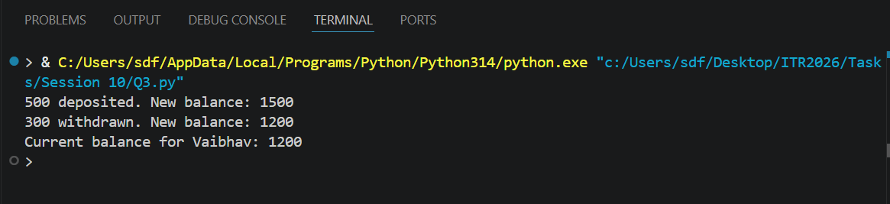

Q4
Q4. Method with Parameters)
Create a class Student with attributes name and marks.
Add a method calculate_grade() that returns "Pass" if marks ≥ 40, otherwise
"Fail".
Create 3 student objects, display their details, and print their grades.
Session 10 (AIML) - Assignment Questions 1

Program Code:
# Create a class Student with attributes name and marks.
class Student:
# Add a method calculate_grade() that returns "Pass" if marks ≥ 40, otherwise Fail
def __init__(self,name,marks):
self.name =name
self.marks =marks
def calculate_grade(self):
if self.marks >= 40:
return "Pass"
else:
return "Fail"
# Create 3 student objects, display their details, and print their grades.
Student1 = Student ("Vaibhav" , 89)
Student2 = Student ("Ram" , 91)
Student3 = Student ("Rahual" , 28)
print("\nStudent Name :", Student1.name,"\nStudent Marks :" ,Student1.marks,"\nStudent Grade:",Student1.calculate_grade())
print("\nStudent Name :", Student2.name,"\nStudent Marks :" ,Student2.marks,"\nStudent Grade:",Student2.calculate_grade())
print("\nStudent Name :", Student3.name,"\nStudent Marks :" ,Student3.marks,"\nStudent Grade:",Student3.calculate_grade())

Output Screenshot: 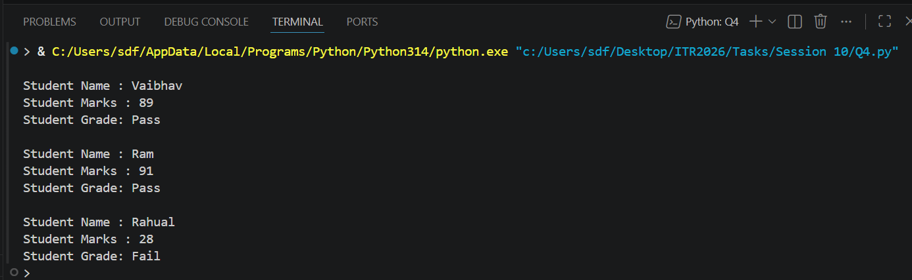

Q5
Q5. Multiple Methods)
Create a class Employee with:
Attributes: name, salary (use __init__).
Methods:
display_details()
give_raise(amount) — increase salary and print new salary.
yearly_bonus() — return 10% of current salary.
Create an employee object and demonstrate all methods.

Program Code:
# Create a class Employee
class Employee:
def __init__(self, name, salary):
self.name = name
self.salary = salary
def display_details(self):
print("Employee Name:", self.name)
print("Employee Salary:", self.salary)
def give_raise(self, amount):
self.salary += amount
print("New Salary after raise:", self.salary)
def yearly_bonus(self):
return self.salary * 0.10
# Create an employee object
emp1 = Employee("Gangadhar", 76000)
# Demonstrate all methods
emp1.display_details()
emp1.give_raise(5000)
bonus = emp1.yearly_bonus()
print("Yearly Bonus:", bonus)

Output Screenshot: 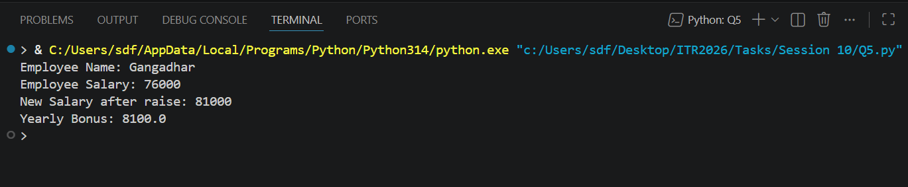

Q6
Q6. Real-world Object Modeling)
Create a class MobilePhone with attributes: brand, model, battery_percentage.
Add these methods:
charge(percent) — increase battery.
use_phone(minutes) — reduce battery by 1% per 10 minutes.
show_status() — print current status.
Create an object and simulate some usage.

Program Code:
# Create a class MobilePhone with attributes: brand, model, battery_percentage.
class MobilePhone:
def __init__(self, brand, model, battery_percentage):
self.brand = brand
self.model = model
self.battery_percentage = battery_percentage
# Increase battery
def charge(self, percent):
self.battery_percentage += percent
if self.battery_percentage > 100:
self.battery_percentage = 100
print("Battery Percentage:", self.battery_percentage, "%")
# Reduce battery by 1% per 10 minutes
def use_phone(self, minutes):
battery_used = minutes // 10
self.battery_percentage -= battery_used
if self.battery_percentage < 0:
self.battery_percentage = 0
print("Battery after usage:", self.battery_percentage, "%")
# Show phone status
def show_status(self):
print("\nBrand:", self.brand)
print("Model:", self.model)
print("Battery:", self.battery_percentage, "%")
# Create object
phone = MobilePhone("Samsung", "Galaxy S24", 80)
# Simulate usage
phone.show_status()
phone.use_phone(30) # Battery decreases by 3%
phone.charge(10) # Battery increases by 10%
phone.show_status()

Output Screenshot: 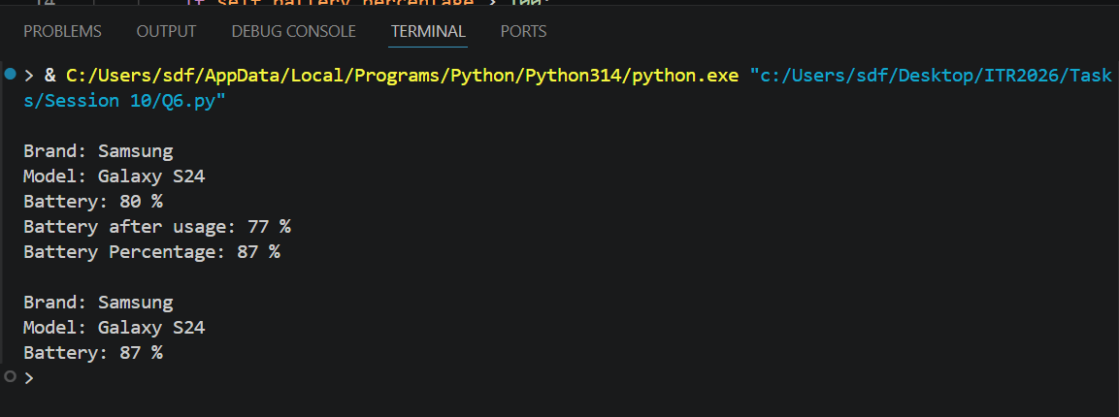

Q7
Q7. Combining Concepts)
Create a class Rectangle with attributes length and width.
Add methods:
area() — return the area.
perimeter() — return the perimeter.
display() — print length, width, area, and perimeter.
Take input from user for length and width, create object, and display results.

Program Code:
# Create a class Rectangle with attributes length and width.
class Rectangle:
def __init__(self, length, width):
self.length = length
self.width = width
# area() — return the area.
def area(self):
return self.length * self.width
# perimeter() — return the perimeter.
def perimeter(self):
return 2 * (self.length + self.width)
# display() — print length, width, area, and perimeter.
def display(self):
print("\nLength:", self.length)
print("Width:", self.width)
print("Area:", self.area())
print("Perimeter:", self.perimeter())
# Take input from user
length = float(input("Enter Length: "))
width = float(input("Enter Width: "))
# Create object
rect = Rectangle(length, width)
# Display results
rect.display()

Output Screenshot: 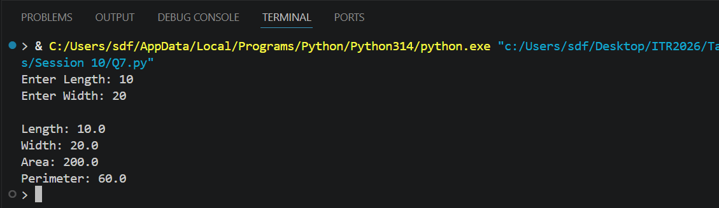

Q8
Q8. Updating Attributes)
Create a class Player with attributes name, score, and level.
Add methods:
increase_score(points)
level_up() — increase level by 1.
Session 10 (AIML) - Assignment Questions 2
show_progress()
Create an object, update score and level multiple times, and show progress.

Program Code:
class Player:
def __init__(self, name, score, level):
self.name = name
self.score = score
self.level = level
def increase_score(self, points):
self.score += points
print(points, "points added.")
def level_up(self):
self.level += 1
print("Level Up!")
def show_progress(self):
print("\nPlayer Name:", self.name)
print("Score:", self.score)
print("Level:", self.level)
# Create object
player1 = Player("Vaibhav", 100, 1)
# Show initial progress
player1.show_progress()
# Update score and level multiple times
player1.increase_score(50)
player1.level_up()
player1.increase_score(100)
player1.level_up()
# Show final progress
player1.show_progress()

Output Screenshot: 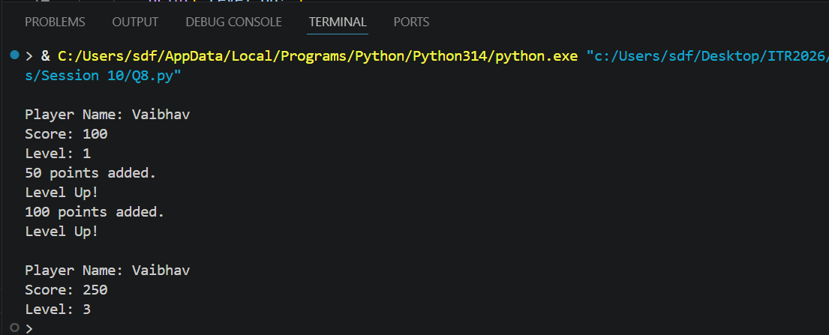

Q9
Q9. Debugging OOP Code)
The following code has errors. Correct it and add proper comments explaining the
fixes:
Python
class Person:
def __init__(name, age):
name = name
age = age
def introduce():
print("My name is" name "and I am" age "years old.")
p1 = Person("Rahul", 25)
p1.introduce()

Program Code:
# Create a class Person
class Person:
# Fixed: Added self parameter
def __init__(self, name, age):
# Fixed: Store values in object attributes
self.name = name
self.age = age
# Fixed: Added self parameter
def introduce(self):
# Fixed: Correct print syntax and use object attributes
print("My name is", self.name, "and I am", self.age, "years old.")
# Create object
p1 = Person("Rahul", 25)
# Call method
p1.introduce()

Output Screenshot: 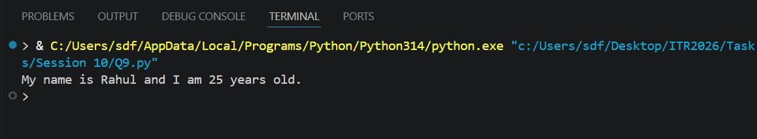

Q10
Q10. Mini Project - Combined OOP
Create a Simple Library Management System using OOP
Design a class Book with:
Attributes: title, author, status ("Available" or "Issued").
Methods: issue_book(), return_book(), show_info().
Create multiple book objects and demonstrate issuing/returning books with proper
messages.
Use a menu (while loop) to allow the user to:
Add a new book
Issue a book
Return a book
Show all books
Session 10 (AIML) - Assignment Questions 3
Exit
Session 10 (AIML) - Assignment Questions 4

Program Code:
class Book:
def __init__(self, title, author):
self.title = title
self.author = author
self.status = "Available"
def issue_book(self):
if self.status == "Available":
self.status = "Issued"
print("Book issued successfully.")
else:
print("Book is already issued.")
def return_book(self):
if self.status == "Issued":
self.status = "Available"
print("Book returned successfully.")
else:
print("Book is already available.")
def show_info(self):
print("\nTitle :", self.title)
print("Author:", self.author)
print("Status:", self.status)
# List to store book objects
library = []
while True:
print("\n===== Library Management System =====")
print("1. Add New Book")
print("2. Issue Book")
print("3. Return Book")
print("4. Show All Books")
print("5. Exit")
choice = input("Enter your choice: ")
# Add Book
if choice == "1":
title = input("Enter Book Title: ")
author = input("Enter Author Name: ")
book = Book(title, author)
library.append(book)
print("Book added successfully.")
# Issue Book
elif choice == "2":
title = input("Enter Book Title to Issue: ")
found = False
for book in library:
if book.title.lower() == title.lower():
book.issue_book()
found = True
break
if not found:
print("Book not found.")
# Return Book
elif choice == "3":
title = input("Enter Book Title to Return: ")
found = False
for book in library:
if book.title.lower() == title.lower():
book.return_book()
found = True
break
if not found:
print("Book not found.")
# Show All Books
elif choice == "4":
if len(library) == 0:
print("No books available.")
else:
for book in library:
book.show_info()
# Exit
elif choice == "5":
print("Thank You!")
break
else:
print("Invalid Choice.")

Output Screenshot: 